Below is a ready-to-use consent framework for SproutSong / SproutMentors. This covers form-level consent text, module-wise consent text, and a technical mechanism to store proof of consent with timestamp, user details, IP, user agent, checkbox status, privacy-policy version, and audit logs.

This should be reviewed once by a legal/compliance professional before production use, but technically this is the structure I recommend for your platform.

1. Core Consent Rules for SproutSong

Consent should be:

Clear — written in simple language.
Specific — separate consent for separate purposes.
Informed — user should know what data is collected, why, who can access it, how long it is stored, and how to withdraw consent.
Affirmative — checkbox must be unchecked by default; user must actively tick it.
Recorded — store proof in database with timestamp, IP, user agent, policy version, form name, and consent text version.

For children’s data, the DPDP Act requires verifiable consent of the parent/lawful guardian before processing a child’s personal data, and it restricts processing that may negatively affect a child’s wellbeing. Your internal DPDP guide also correctly says not to rely only on a simple checkbox for sensitive student workflows and recommends storing parental consent with timestamp, IP, and the parent contact used.

---

2. Consent Types You Should Maintain

Instead of one common checkbox everywhere, keep separate consent types.

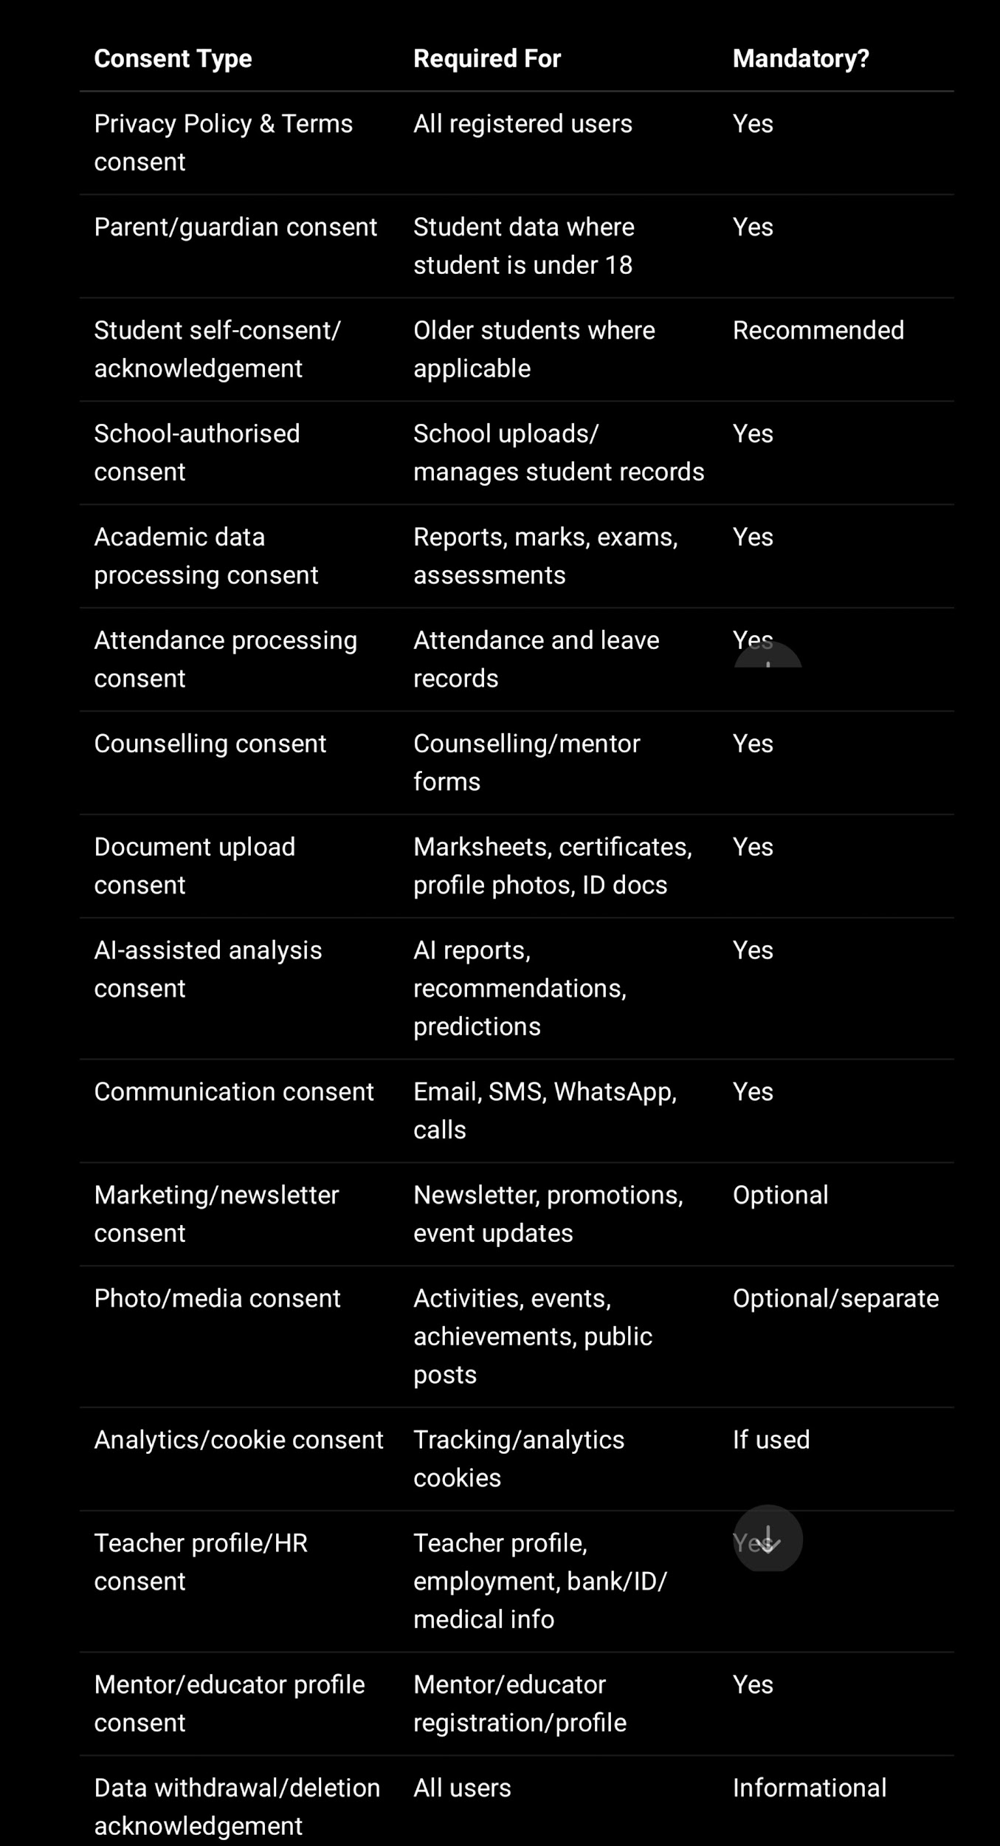

Your existing report already identifies that consent checkboxes are required for student registration, parent registration, teacher profile, mentor profile, AI report generation, document upload, contact/demo forms, and newsletter forms.

---

3. Global Consent Text for Registration

Use this for all account registrations: student, parent, teacher, mentor, educator, principal, school admin.

I confirm that the information provided by me is accurate.

I agree to SproutSong / SproutMentors collecting, storing, and processing my personal data for account creation, login, platform access, communication, security, support, and service delivery purposes.

I have read and agree to the Privacy Policy and Terms of Use. I understand that I may request access, correction, withdrawal of consent, or deletion of my personal data by contacting privacy@sproutsong.com.

Checkbox label:

☐ I agree to the Privacy Policy, Terms of Use, and data processing described above.

Backend rule:

required: true
unchecked by default
form submit blocked if false

---

4. Form-Wise Consent Drafts

4.1 School Onboarding Form

Use when a school/principal/admin registers the institution.

I confirm that I am authorised to submit this school/institution information on behalf of the school.

I consent to SproutSong / SproutMentors collecting and processing the school’s institutional information, contact details, staff/admin details, and onboarding information for school account creation, platform setup, service activation, communication, training, support, and administration.

I understand that authorised SproutSong team members and authorised school users may access this information only for onboarding, operations, support, and compliance purposes.

Checkbox:

☐ I am authorised by the school and consent to processing this information for onboarding and platform administration.

---

4.2 Demo Request Form

Your form security guide already proposes this type of consent for demo requests and recommends storing consentGiven, consentTimestamp, and consentIP.

By submitting this form, I confirm that the information provided is accurate and I consent to SproutSong processing this data to schedule a product demonstration, contact me for follow-up, and assess fit for SproutSong’s services.

I understand that:
• My data will be retained for up to 12 months after the last contact.
• I can request deletion by emailing privacy@sproutsong.com.
• SproutSong will not share my data with third parties for marketing.
• I can withdraw this consent at any time.

Checkbox:

☐ I consent to SproutSong contacting me for demo scheduling and follow-up communication.

Marketing should be separate:

☐ I would also like to receive SproutSong updates, newsletters, and event information.

Do not make marketing consent mandatory.

---

4.3 Contact Us Form

I consent to SproutSong / SproutMentors collecting and processing my name, contact details, message, and related information to respond to my enquiry, provide support, and maintain communication regarding my request.

I understand that my data will not be used for unrelated marketing unless I separately agree to receive updates.

Checkbox:

☐ I consent to the processing of my information for responding to this enquiry.

Optional:

☐ I agree to receive future updates, newsletters, and event information from SproutSong.

---

4.4 Newsletter Form

I consent to SproutSong using my name and email address to send newsletters, educational updates, event announcements, and product-related communication.

I understand that I can unsubscribe at any time using the unsubscribe link or by contacting privacy@sproutsong.com.

Checkbox:

☐ I agree to receive newsletters and updates from SproutSong.

---

4.5 Student Registration Form

For student registration, use two layers: school-authorised consent and parent/guardian consent.

A. If school/admin creates student record

I confirm that I am authorised by the school/institution to create or update this student record on SproutSong / SproutMentors.

I confirm that the school has obtained the required consent/authorisation from the parent or lawful guardian where applicable, and that the student information is being submitted for educational, academic, administrative, attendance, communication, reporting, and student support purposes.

I understand that student data will be accessed only by authorised school staff, teachers, parents/guardians, and platform administrators as required for educational purposes.

Checkbox:

☐ I confirm school authorisation and consent basis for creating this student record.

B. If parent directly submits student registration

I confirm that I am the parent or lawful guardian of the student named above.

I consent to SproutSong / SproutMentors collecting, storing, and processing the student’s personal, academic, class, attendance, communication, and profile information for educational administration, academic tracking, reporting, communication, and student support purposes.

I understand that the data will be accessed only by authorised school staff, assigned teachers, authorised mentors/counsellors, parents/guardians, and platform administrators as required.

Checkbox:

☐ I confirm that I am the parent/lawful guardian and consent to processing the student’s data.

For minors, the form should not submit unless parentConsentGiven = true. Your form security guide says the system should derive isMinor from DOB server-side and enforce parent consent before saving minor records.

---

4.6 Parent Registration Form

I consent to SproutSong / SproutMentors collecting and processing my personal and contact information to create my parent/guardian account, link me with my child’s school records, provide access to my child’s academic reports, attendance, homework, communication, and school updates.

I understand that my access will be limited to my linked child/children only and that I must not access, share, or misuse another student’s information.

Checkbox:

☐ I consent to creating my parent/guardian account and linking it with my child’s records.

---

4.7 Teacher Registration / Teacher Profile Form

Teacher profiles are high-risk because your uploaded data/report includes bank, identity, family, medical, and professional data. Your DPDP report recommends restricting sensitive teacher details like bank, identity, family, and medical information to authorised users only.

I consent to SproutSong / SproutMentors collecting, storing, and processing my teacher profile information for employment, institutional records, academic administration, class allocation, timetable management, communication, and school operations.

I understand that sensitive information such as identity documents, bank details, family details, and medical information will be used only for authorised HR, administrative, compliance, payroll, or institutional purposes and will be restricted to authorised users only.

I confirm that the information provided is accurate and I understand that I may request correction or deletion where applicable by contacting the school administrator or privacy@sproutsong.com.

Checkbox:

☐ I consent to processing my teacher profile information for school and platform operations.

For sensitive sections, add separate checkboxes:

☐ I consent to processing my identity/KYC information for verification and institutional compliance purposes.

☐ I consent to processing my bank/payment information for payroll, reimbursement, or authorised financial administration purposes.

☐ I consent to processing my medical/emergency information only for safety, emergency, and authorised HR purposes.

---

4.8 Mentor / Counsellor Profile Form

I consent to SproutSong / SproutMentors collecting and processing my mentor/counsellor profile, qualification, contact, experience, availability, and professional information for profile creation, student assignment, counselling operations, communication, and service delivery.

I understand that my profile may be visible to authorised school users, assigned students/parents, and platform administrators depending on the platform settings.

Checkbox:

☐ I consent to processing my mentor/counsellor profile for counselling and student support services.

---

4.9 Counselling Form

This is one of the highest-risk forms because it may collect student identity, parent details, financial data, academic records, documents, interests, preferences, and counselling notes. Your form security guide classifies the counselling form as very high risk and says verifiable parental consent is mandatory for students under 18.

Use two mandatory consents.

Consent 1 — Parent/Guardian Consent

I confirm that I am the parent or lawful guardian of the student named in this form.

I consent to SproutSong / SproutMentors collecting, storing, and processing the student’s personal information, academic information, marksheets, documents, interests, preferences, and counselling-related information for educational counselling, career guidance, academic analysis, and report generation purposes only.

I understand that counselling recommendations are guidance-based and should be reviewed by the student, parent/guardian, counsellor, and/or school before making final academic or career decisions.

I understand that I may request access, correction, withdrawal of consent, or deletion of this data by contacting privacy@sproutsong.com.

Checkbox:

☐ I confirm that I am the parent/lawful guardian and consent to counselling-related data processing.

Consent 2 — Student Acknowledgement, where appropriate

I understand that my academic information, interests, preferences, and documents may be used to provide counselling, academic guidance, and career recommendations.

I understand that the recommendations are for guidance and discussion, not a final decision.

Checkbox:

☐ I understand and agree to participate in counselling/guidance support.

Consent 3 — Financial Information, if collected

I understand that family financial information, if provided, will be used only to understand affordability, scholarship possibilities, course planning, or counselling context.

I understand that this information is optional unless specifically required for a stated counselling purpose and will be restricted to authorised counsellors/admin users only.

Checkbox:

☐ I consent to processing family financial information for counselling and guidance purposes.

Your existing form guide recommends nulling financial data after case closure as data minimisation.

---

4.10 Marksheet / Document Upload Consent

Your internal documents already recommend adding a specific document upload warning and consent for marksheets, reports, certificates, profile photos, ID documents, medical documents, and teacher documents.

I understand that uploaded documents such as marksheets, certificates, reports, photographs, or identity/qualification documents may contain personal data.

I confirm that I am authorised to upload these documents.

I consent to SproutSong / SproutMentors using these documents only for the stated educational, academic, counselling, verification, or administrative purpose.

I understand that uploaded documents will be stored securely, accessed only by authorised users, and deleted according to the applicable retention policy or upon valid deletion request.

Checkbox:

☐ I confirm that I am authorised to upload these documents and consent to their use for the stated purpose.

Upload warning shown above upload button:

Please upload only the required document. Do not upload unnecessary sensitive personal information.

---

4.11 Attendance Module Consent / Notice

For attendance, consent may be part of school/student onboarding notice rather than every daily attendance action.

I understand that SproutSong / SproutMentors may process student attendance records, absence status, leave records, and limited absence reason categories for school administration, academic participation tracking, parent communication, safety, and reporting purposes.

Absence reasons should be limited to necessary information only and should not include unnecessary medical or family details.

Checkbox during onboarding:

☐ I consent to processing attendance data for school administration, communication, and student support.

Your DPDP report specifically warns that attendance reasons can become sensitive if they include illness, family problems, medical reasons, or personal circumstances.

---

4.12 Homework / Assignments / Tasks / Projects Consent

I understand that SproutSong / SproutMentors may process homework, assignments, project submissions, teacher feedback, activity status, and related academic records to support teaching, learning, evaluation, reporting, and communication between students, teachers, parents, and the school.

I understand that student submissions and feedback will be accessible only to authorised users such as the student, parent/guardian, assigned teacher, school admin, and platform administrators where required.

Checkbox during onboarding:

☐ I consent to processing homework, assignment, task, and project-related academic data.

---

4.13 Exams / Assessments Consent

I consent to SproutSong / SproutMentors processing exam records, assessment responses, marks, grades, teacher remarks, progress indicators, and academic performance data for evaluation, reporting, academic planning, student support, and school administration.

I understand that results and reports will be shared only with authorised users such as the student, parent/guardian, assigned teachers, school administrators, and authorised mentors/counsellors where applicable.

Checkbox:

☐ I consent to processing exam, assessment, and academic performance data.

---

4.14 Reports Module Consent

I consent to SproutSong / SproutMentors generating and storing academic, attendance, assessment, counselling, progress, and student support reports based on the information available in the platform.

I understand that reports may include academic observations, recommendations, and performance summaries, and that they are intended for educational support and school/parent review.

Checkbox:

☐ I consent to generating and storing student reports for educational support and review.

For reports sent by email:

☐ I consent to receiving student reports and platform communication by email/SMS/WhatsApp on the registered contact details.

---

4.15 AI Report / AI-Assisted Analysis Consent

This should always be separate and explicit. Your DPDP report recommends adding AI consent, anonymising student data before AI processing, logging AI usage, requiring human review, and not using student data for AI training unless separately consented.

I understand that SproutSong / SproutMentors may use AI-assisted or technology-assisted analysis to generate educational insights, performance summaries, counselling recommendations, learning suggestions, or parent-ready reports.

I consent to the use of the student’s academic and counselling-related data for AI-assisted analysis for educational guidance and student support purposes only.

I understand that:
• AI output is assistive and not a final decision.
• AI-generated insights should be reviewed by a teacher, mentor, counsellor, parent/guardian, or school authority before use.
• SproutSong will avoid unnecessary personal identifiers where possible.
• Student data will not be used for advertising or harmful profiling.
• Student data will not be used to train third-party AI models unless separately and explicitly consented.

Checkbox:

☐ I consent to AI-assisted educational analysis and report generation.

Separate optional consent if ever needed:

☐ I separately consent to anonymised student data being used to improve SproutSong’s internal educational analytics models.

Keep this optional, not mandatory.

---

4.16 Activities / Events / Photos / Media Consent

Use when school posts photos, activity participation, achievements, event records, social media, or marketing material.

I consent to SproutSong / SproutMentors and/or the school processing activity participation details, event records, achievements, photographs, or media related to the student for school activity management, certificates, internal communication, and parent updates.

I understand that public use of student photos, videos, names, or achievements for website, brochure, social media, or promotional purposes requires separate media/publication consent.

Internal activity checkbox:

☐ I consent to processing activity and event participation data for school and parent communication.

Public media checkbox:

☐ I consent to the use of student photos/videos/name/achievements for public school/SproutSong communication such as website, brochure, or social media.

This should be optional and separate.

---

4.17 Communication Consent: Email / SMS / WhatsApp / Calls

I consent to SproutSong / SproutMentors and/or the school contacting me through email, SMS, WhatsApp, phone call, or platform notification for academic updates, attendance alerts, reports, counselling communication, school announcements, security alerts, and support-related communication.

I understand that essential service and security communications may be necessary for platform operation, while promotional communication can be withdrawn separately.

Checkbox:

☐ I consent to receiving platform, academic, school, and support communication on my registered contact details.
Separate optional marketing:

Separate optional marketing:

☐ I consent to receiving promotional updates, workshops, newsletters, and event announcements.

—

4.18 Analytics / Cookies Consent
Use if you use Google Analytics, tracking pixels, session analytics, heatmaps, etc. :

We use cookies and analytics tools to understand platform usage, improve performance, secure user sessions, and improve our services.

Essential cookies are required for login, security, and platform functionality. Optional analytics cookies help us improve the platform and are used only with your consent where required.

Options:

☐ Allow essential cookies only.
☐ Allow essential + analytics cookies.
☐ Allow essential + analytics + communication preference tracking.

Do not make analytics mandatory unless it is strictly essential.

—

4.19 Data Deletion / Withdrawal Request Consent Notice
This is not a checkbox every time, but it should appear in privacy notice and user profile :

You may request access, correction, withdrawal of consent, or deletion of your personal data by contacting privacy@sproutsong.com.

If the request relates to a student under 18, the request must be made or verified by the parent/lawful guardian or authorised school representative.

Some data may need to be retained for legal, academic, safety, audit, or school administration purposes where applicable.

Your documents also recommend providing a clear privacy contact and withdrawal/deletion option on forms.

—

5. Module-Wise Consent Mapping

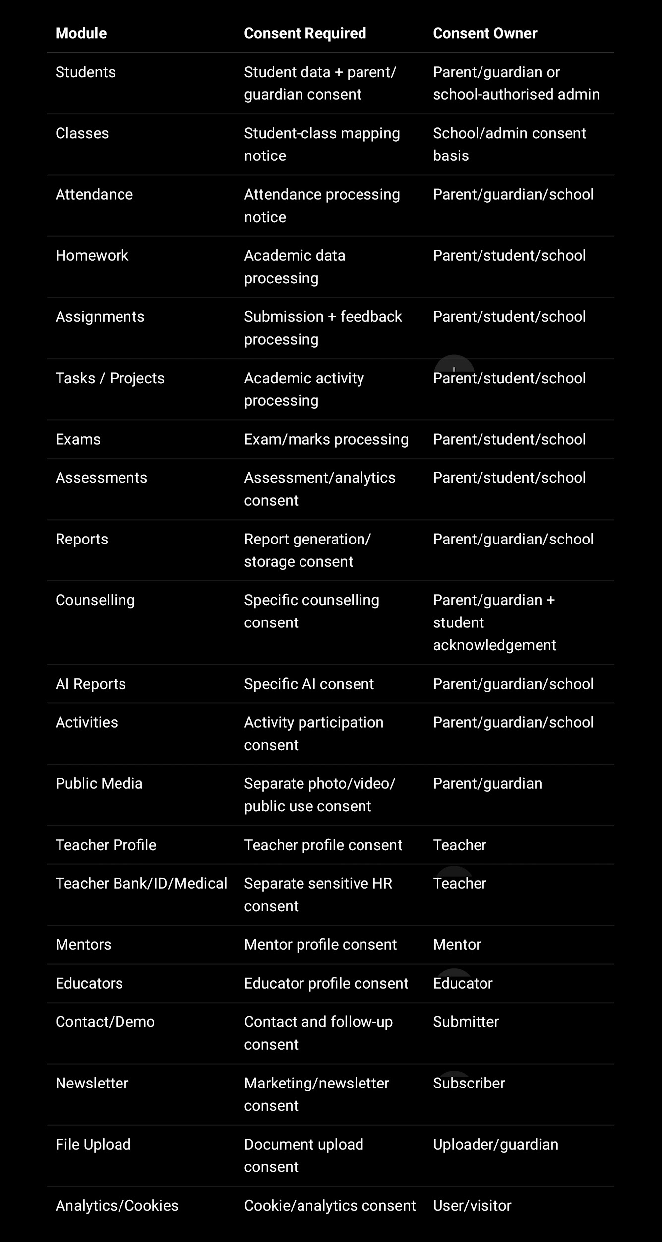
—

6. Consent Storage Mechanism

Create a separate consents collection. Do not store only consentGiven: true inside the main form record. Store full proof in a dedicated collection and reference it from the related module record.

Recommended consents schema

const ConsentSchema = new mongoose.Schema({
consentId: {
type: String,
unique: true,
index: true
},

schoolId: {
type: mongoose.Schema.Types.ObjectId,
ref: "School",
index: true
},

dataPrincipalType: {
type: String,
enum: [
"STUDENT",
"PARENT",
"TEACHER",
"MENTOR",
"EDUCATOR",
"SCHOOL_ADMIN",
"VISITOR"
],
required: true
},

dataPrincipalId: {
type: mongoose.Schema.Types.ObjectId,
index: true
},

givenByType: {
type: String,
enum: [
"SELF",
"PARENT",
"GUARDIAN",
"SCHOOL_AUTHORISED_PERSON",
"TEACHER",
"ADMIN",
"VISITOR"
],
required: true
},

givenByUserId: {
type: mongoose.Schema.Types.ObjectId,
ref: "User",
index: true
},

givenByName: {
type: String
},

givenByEmailHash: {
type: String
},

givenByMobileHash: {
type: String
},

relationshipToStudent: {
type: String,
enum: ["FATHER", "MOTHER", "GUARDIAN", "SCHOOL_ADMIN", "SELF", "OTHER"],
default: "SELF"
},

studentId: {
type: mongoose.Schema.Types.ObjectId,
ref: "Student",
index: true
},

isMinor: {
type: Boolean,
default: false
},

consentType: {
type: String,
enum: [
"PRIVACY_TERMS",
"STUDENT_REGISTRATION",
"PARENT_GUARDIAN",
"SCHOOL_AUTHORISED_STUDENT_UPLOAD",
"ACADEMIC_PROCESSING",
"ATTENDANCE_PROCESSING",
"EXAM_ASSESSMENT_PROCESSING",
"REPORT_GENERATION",
"COUNSELLING",
"DOCUMENT_UPLOAD",
"AI_ANALYSIS",
"COMMUNICATION",
"MARKETING_NEWSLETTER",
"PHOTO_MEDIA_INTERNAL",
"PHOTO_MEDIA_PUBLIC",
"TEACHER_PROFILE",
"TEACHER_IDENTITY_KYC",
"TEACHER_BANK_PAYROLL",
"TEACHER_MEDICAL_EMERGENCY",
"MENTOR_PROFILE",
"EDUCATOR_PROFILE",
"CONTACT_FORM",
"DEMO_REQUEST",
"COOKIES_ANALYTICS"
],
required: true,
index: true
},

module: {
type: String,
index: true
},

formName: {
type: String
},

relatedRecordType: {
type: String
},

relatedRecordId: {
type: mongoose.Schema.Types.ObjectId,
index: true
},

consentText: {
type: String,
required: true
},

consentTextHash: {
type: String,
required: true
},

consentVersion: {
type: String,
required: true
},

privacyPolicyVersion: {
type: String,
required: true
},

termsVersion: {
type: String
},

checkboxLabel: {
type: String
},

checkboxChecked: {
type: Boolean,
required: true
},

agreed: {
type: Boolean,
required: true,
index: true
},

agreedAt: {
type: Date,
required: true,
index: true
},

ipAddress: {
type: String
},

userAgent: {
type: String
},

deviceInfo: {
type: Object
},

source: {
type: String,
enum: ["WEB", "MOBILE_APP", "ADMIN_PANEL", "SCHOOL_UPLOAD", "API", "IMPORT"],
default: "WEB"
},

verificationMethod: {
type: String,
enum: ["CHECKBOX", "OTP", "EMAIL_LINK", "SCHOOL_AUTHORITY", "DIGILOCKER", "MANUAL_VERIFICATION"],
default: "CHECKBOX"
},

verificationStatus: {
type: String,
enum: ["PENDING", "VERIFIED", "FAILED", "NOT_REQUIRED"],
default: "NOT_REQUIRED"
},

otpVerifiedAt: Date,
emailVerifiedAt: Date,

withdrawn: {
type: Boolean,
default: false,
index: true
},

withdrawnAt: Date,
withdrawalReason: String,

retentionUntil: Date,

requestId: {
type: String,
index: true
}
}, {
timestamps: true
});

ConsentSchema.index({ schoolId: 1, dataPrincipalId: 1, consentType: 1 });
ConsentSchema.index({ studentId: 1, consentType: 1, agreedAt: -1 });
ConsentSchema.index({ relatedRecordId: 1, consentType: 1 });

Your DPDP report already recommends adding fields like consentRefId, privacyPolicyVersion, termsVersion, ipAddress, userAgent, and retentionUntil across collections.

—

7. Consent Versioning

Create a separate consent_templates collection.

const ConsentTemplateSchema = new mongoose.Schema({
consentType: {
type: String,
required: true,
index: true
},

version: {
type: String,
required: true
},

title: String,

text: {
type: String,
required: true
},

textHash: {
type: String,
required: true
},

language: {
type: String,
default: "en"
},

privacyPolicyVersion: String,
termsVersion: String,

effectiveFrom: Date,
effectiveTo: Date,

isActive: {
type: Boolean,
default: true
},

createdBy: mongoose.Schema.Types.ObjectId
}, {
timestamps: true
});

ConsentTemplateSchema.index(
{ consentType: 1, version: 1, language: 1 },
{ unique: true }
);

Why this is important:

When you update consent text later, you must know which exact text the user agreed to. Storing only true is weak proof. Store text version and hash.

—

8. Backend Consent Capture Flow

Step 1: Frontend sends checkbox value
{
studentName: "Student Name",
parentName: "Parent Name",
parentMobile: "9876543210",

consents: [
{
consentType: "PARENT_GUARDIAN",
checkboxChecked: true,
consentVersion: "v1.0"
},
{
consentType: "DOCUMENT_UPLOAD",
checkboxChecked: true,
consentVersion: "v1.0"
}
]
}

Step 2: Backend verifies active consent template

const crypto = require("crypto");

function sha256(value) {
return crypto.createHash("sha256").update(value).digest("hex");
}
Step 3: Store consent server-side

async function recordConsent({
req,
schoolId,
dataPrincipalType,
dataPrincipalId,
studentId,
givenByType,
givenByUserId,
givenByName,
relationshipToStudent,
consentType,
module,
formName,
relatedRecordType,
relatedRecordId,
checkboxLabel,
source = "WEB",
verificationMethod = "CHECKBOX"
}) {
const template = await ConsentTemplate.findOne({
consentType,
isActive: true
});

if (!template) {
throw new Error(`Active consent template not found for ${consentType}`);
}

return Consent.create({
consentId: crypto.randomUUID(),

schoolId,

dataPrincipalType,
dataPrincipalId,

studentId,

givenByType,
givenByUserId,
givenByName,
relationshipToStudent,

consentType,
module,
formName,

relatedRecordType,
relatedRecordId,

consentText: template.text,
consentTextHash: sha256(template.text),
consentVersion: template.version,
privacyPolicyVersion: template.privacyPolicyVersion,
termsVersion: template.termsVersion,

checkboxLabel,
checkboxChecked: true,
agreed: true,
agreedAt: new Date(),

ipAddress: req.ip,
userAgent: req.headers["user-agent"],
requestId: req.requestId,

source,
verificationMethod,
verificationStatus: verificationMethod === "CHECKBOX" ? "NOT_REQUIRED" : "PENDING"
});
}

—

9. Validation Rule: Consent Must Be Checked

function requireConsent(requiredConsentTypes = []) {
return (req, res, next) => {
const consents = req.body.consents || [];

for (const type of requiredConsentTypes) {
const found = consents.find(
c => c.consentType === type && c.checkboxChecked === true
);

if (!found) {
return res.status(400).json({
success: false,
code: "CONSENT_REQUIRED",
message: `${type} consent is required.`
});
}
}

next();
};
}

Example:

router.post(
"/counselling",
verifyCaptcha,
validateCounsellingForm,
requireConsent(["PARENT_GUARDIAN", "DOCUMENT_UPLOAD", "COUNSELLING"]),
createCounsellingRequest
);

For AI:

router.post(
"/ai-report/generate",
authenticate,
authorize("aiReports", "create"),
requireConsent(["AI_ANALYSIS"]),
generateAiReport
);

—

10. Parent / Guardian Verifiable Consent Mechanism

For sensitive minor/student workflows, do not rely only on checkbox. Use OTP or email verification.

Recommended flow:

- Parent enters mobile/email.
- System sends OTP/email verification link.
- Parent checks consent checkbox.
- Parent verifies OTP.
- Consent is stored with:

- parent name
- relationship
- mobile/email hash
- IP
- user agent
- timestamp
- OTP verified timestamp
- consent version
- privacy policy version

parentConsent: {
required: true,
given: true,
guardianName: "Parent Name",
relationship: "FATHER",
mobileHash: "hashed_mobile",
emailHash: "hashed_email",
consentAt: new Date(),
consentIp: req.ip,
verificationMethod: "OTP",
otpVerifiedAt: new Date(),
consentRefId: consent._id
}

The official DPDP Act provision specifically requires verifiable consent for child data, and your internal guidance also notes that parent/guardian consent should not be just a simple checkbox for sensitive workflows.

—

11. Store Consent Reference in Main Collections

In each module record, keep only reference fields:

{
consentRefs: [
{
consentType: "PARENT_GUARDIAN",
consentId: ObjectId("...")
},
{
consentType: "DOCUMENT_UPLOAD",
consentId: ObjectId("...")
}
],

consentSummary: {
hasRequiredConsent: true,
latestConsentAt: Date,
privacyPolicyVersion: "v1.0",
termsVersion: "v1.0"
}
}

Add to:

students
parents
teachers
teacherprofiles
mentors
educators
counsellingRequests
reports
aiReports
documents
contacts
demoRequests
newsletterSubscribers

—

12. Consent Audit Log

Whenever consent is created, withdrawn, updated, or rejected, create an audit log.

await AuditLog.create({
requestId: req.requestId,
actorId: req.user?._id || null,
actorRole: req.user?.role || "PUBLIC",
schoolId,

module: "consents",
action: "CONSENT_AGREED",
result: "allowed",

recordType: "Consent",
recordId: consent._id,

ipAddress: req.ip,
userAgent: req.headers["user-agent"],

metadata: {
consentType,
consentVersion: consent.consentVersion,
privacyPolicyVersion: consent.privacyPolicyVersion,
relatedRecordType,
relatedRecordId
},

createdAt: new Date()
});

Your secure logging guide recommends using audit logs for security events and warns never to log passwords, tokens, full email, phone, student names, DOB, counselling notes, full request bodies, or response bodies.

—

13. Consent Withdrawal Flow

Create data_requests collection.

const DataRequestSchema = new mongoose.Schema({
requestType: {
type: String,
enum: ["ACCESS", "CORRECTION", "DELETION", "CONSENT_WITHDRAWAL", "GRIEVANCE"],
required: true
},

requesterUserId: mongoose.Schema.Types.ObjectId,
requesterName: String,
requesterEmailHash: String,
requesterMobileHash: String,

studentId: mongoose.Schema.Types.ObjectId,
schoolId: mongoose.Schema.Types.ObjectId,

description: String,

status: {
type: String,
enum: ["PENDING", "IN_REVIEW", "APPROVED", "REJECTED", "COMPLETED"],
default: "PENDING"
},

assignedTo: mongoose.Schema.Types.ObjectId,

verified: {
type: Boolean,
default: false
},

verifiedAt: Date,
closedAt: Date,

responseNote: String
}, {
timestamps: true
});

When withdrawal is accepted:

await Consent.updateMany(
{
dataPrincipalId,
consentType,
withdrawn: false
},
{
$set: {
withdrawn: true,
withdrawnAt: new Date(),
withdrawalReason: "User requested withdrawal"
}
}
);

Important: some data may need to remain for academic/legal/audit purposes, but processing should stop where possible. Keep this clearly explained in Privacy Policy.

—

14. Frontend Consent UI Example

<label className="consent-box">
<input
type="checkbox"
name="parentConsent"
checked={values.parentConsent}
onChange={handleChange}
required
/>
<span>
I confirm that I am the parent/lawful guardian and consent to
SproutSong processing the student's personal and academic data for
educational guidance and school support purposes.
<a href="/privacy-policy" target="_blank"> Privacy Policy </a>
and
<a href="/terms" target="_blank"> Terms of Use </a>.
</span>
</label>

Rules:

Checkbox unchecked by default.
No pre-ticked consent.
Each purpose should have its own checkbox.
Show Privacy Policy and Terms links beside checkbox.
Store timestamp on backend, not frontend.
Frontend cannot be proof by itself; backend DB entry is proof.
—
15. Final Recommended Consent Package

You should create these documents/pages:

- Privacy Policy
- Terms of Use
- Child Data Protection Policy
- Parent/Guardian Consent Policy
- AI Usage & Student Safety Policy
- Data Retention Policy
- Data Deletion / Withdrawal SOP
- Cookie Policy
- School Data Processing Agreement
- Consent Template Version Register

Your teamship guide also recommends Privacy Policy, Terms, Child Data Protection Policy, School Data Processing Agreement, Consent Policy, Data Retention Policy, Breach Response Policy, Cookie Policy, and AI Usage Disclaimer.

—

16. Practical Implementation Order

Start with these consent implementations first:

- Student registration — parent/school-authorised consent
- Counselling form — parent/guardian + document upload + counselling consent
- AI report generation — separate AI consent
- Document upload — upload-specific consent
- Teacher profile — teacher + sensitive HR sections consent
- Contact/demo/newsletter forms — public form consent
- Communication consent — email/SMS/WhatsApp
- Photo/media consent — separate optional consent

Minimum technical fields to store for every consent:

{
consentType,
agreed: true,
checkboxChecked: true,
agreedAt: new Date(),
givenByUserId,
givenByName,
dataPrincipalId,
studentId,
schoolId,
relationshipToStudent,
consentText,
consentTextHash,
consentVersion,
privacyPolicyVersion,
termsVersion,
ipAddress,
userAgent,
requestId,
source,
verificationMethod,
verificationStatus
}

This gives you strong proof that the user actively agreed, what exactly they agreed to, when they agreed, from where, for which module, and under which policy version.

